Neeraj Appari S073

Advance Java Practical 8

Aim: Create Employees table in EMP database. Perform select, insert, update, and delete operations on Employee table using JSP

HTML

HOME.html

<!DOCTYPE html>

<!--

To change this license header, choose License Headers in Project Properties.

To change this template file, choose Tools | Templates

and open the template in the editor.

-->

<html>

<head>

<title>TODO supply a title</title>

<meta charset="UTF-8">

<meta name="viewport" content="width=device-width, initial-scale=1.0">

</head>

<body>

<div>Employee</div>

<a href="p8add.html" target="_blank">Add Record</a>

<a href="p8upd.html" target="_blank">Update Record</a>

<a href="p8del.html" target="_blank">Delete Record</a>

<a href="p8ser.html" target="_blank">View Record</a>

</body>

</html>

ADD.html

<!DOCTYPE html>

<!--

To change this license header, choose License Headers in Project Properties.

To change this template file, choose Tools | Templates

and open the template in the editor.

-->

<html>

<head>

<title>TODO supply a title</title>

<meta charset="UTF-8">

<meta name="viewport" content="width=device-width, initial-scale=1.0">

</head>

<body>

<form action="Add.jsp">

Roll No<input type="text" name="txtrn" value="" /><br>

Name<input type="text" name="txtnm" value="" /><br>

<input type="submit" value="Add" />

</form>

</body>

</html>

Update.html

<!DOCTYPE html>

<!--

To change this license header, choose License Headers in Project Properties.

To change this template file, choose Tools | Templates

and open the template in the editor.

-->

<html>

<head>

<title>TODO supply a title</title>

<meta charset="UTF-8">

<meta name="viewport" content="width=device-width, initial-scale=1.0">

</head>

<body>

<form action="Upd.jsp">

Roll No<input type="text" name="txtrn" value="" /><br>

Name<input type="text" name="txtnm" value="" /><br>

<input type="submit" value="Update" />

</form>

</body>

</html>

Delete.html

<!DOCTYPE html>

<!--

To change this license header, choose License Headers in Project Properties.

To change this template file, choose Tools | Templates

and open the template in the editor.

-->

<html>

<head>

<title>TODO supply a title</title>

<meta charset="UTF-8">

<meta name="viewport" content="width=device-width, initial-scale=1.0">

</head>

<body>

<form action="Del.jsp">

Roll No<input type="text" name="txtrn" value="" /><br>

<input type="submit" value="Delete" />

</form>

</body>

</html>

Search.html

<!DOCTYPE html>

<!--

To change this license header, choose License Headers in Project Properties.

To change this template file, choose Tools | Templates

and open the template in the editor.

-->

<html>

<head>

<title>TODO supply a title</title>

<meta charset="UTF-8">

<meta name="viewport" content="width=device-width, initial-scale=1.0">

</head>

<body>

<form action="Ser.jsp">

Roll No<input type="text" name="txtrn" value="" /><br>

<input type="submit" value="View" />

</form>

</body>

</html>

JSP

Add.jsp

<%--

Document : Add

Created on : 28 Mar, 2021, 4:15:08 PM

Author : LAXMINARAYANRO

--%>

<%@page contentType="text/html" pageEncoding="UTF-8"%>

<%@page import="java.sql.*" %>

<!DOCTYPE html>

<html>

<head>

<meta http-equiv="Content-Type" content="text/html; charset=UTF-8">

<title>JSP Page</title>

</head>

<body>

<h1>Add Record</h1>

<%

try

{

int rn = Integer.parseInt(request.getParameter("txtrn"));

String sn = request.getParameter("txtnm");

Class.forName("org.apache.derby.jdbc.EmbeddedDriver"); // drive class name

Connection cn = DriverManager.getConnection("jdbc:derby://localhost:1527/Employee"); // database path

String str = "insert into Employee values(?,?) ";

PreparedStatement pst = cn.prepareStatement(str);

//pst.setInt(1, 10);

//pst.setString(2, "ghj");

pst.setInt(1, rn);

pst.setString(2, sn);

int i =pst.executeUpdate();

//Statement st = cn.createStatement();

out.println(i + " record inserted successfully ");

}

catch(Exception e)

{

System.out.println("error:"+e.getMessage());

}

%>

</body>

</html>

Update.jsp

<%--

Document : Upd

Created on : 28 Mar, 2021, 4:42:37 PM

Author : LAXMINARAYANRO

--%>

<%@page import="java.sql.PreparedStatement"%>

<%@page import="java.sql.DriverManager"%>

<%@page import="java.sql.Connection"%>

<%@page contentType="text/html" pageEncoding="UTF-8"%>

<!DOCTYPE html>

<html>

<head>

<meta http-equiv="Content-Type" content="text/html; charset=UTF-8">

<title>JSP Page</title>

</head>

<body>

<h1>Update Record</h1>

<%

try

{

int rn = Integer.parseInt(request.getParameter("txtrn"));

String sn = request.getParameter("txtnm");

Class.forName("org.apache.derby.jdbc.EmbeddedDriver"); // drive class name

Connection cn = DriverManager.getConnection("jdbc:derby://localhost:1527/Employee"); // database path

String str = "update Employee set Name='"+sn+"' where Rollno = "+rn+"";

PreparedStatement pst = cn.prepareStatement(str);

//pst.setInt(1, 10);

//pst.setString(2, "ghj");

//pst.setInt(1, rn);

//pst.setString(2, sn);

pst.executeUpdate();

//Statement st = cn.createStatement();

out.println(" record updated successfully ");

}

catch(Exception e)

{

System.out.println("error:"+e.getMessage());

}

%>

</body>

</html>

Delete.jsp

<%--

Document : Del

Created on : 28 Mar, 2021, 4:54:09 PM

Author : LAXMINARAYANRO

--%>

<%@page import="java.sql.PreparedStatement"%>

<%@page import="java.sql.DriverManager"%>

<%@page import="java.sql.Connection"%>

<%@page contentType="text/html" pageEncoding="UTF-8"%>

<!DOCTYPE html>

<html>

<head>

<meta http-equiv="Content-Type" content="text/html; charset=UTF-8">

<title>JSP Page</title>

</head>

<body>

<h1>Delete Record</h1>

<%

try

{

int rn = Integer.parseInt(request.getParameter("txtrn"));

Class.forName("org.apache.derby.jdbc.EmbeddedDriver"); // drive class name

Connection cn = DriverManager.getConnection("jdbc:derby://localhost:1527/Employee"); // database path

String str = "delete from Employee where rollno = ? ";

PreparedStatement pst = cn.prepareStatement(str);

//pst.setInt(1, 10);

//pst.setString(2, "ghj");

pst.setInt(1, rn);

pst.executeUpdate();

//Statement st = cn.createStatement();

out.println(" record deleted successfully ");

}

catch(Exception e)

{

System.out.println("error:"+e.getMessage());

}

%>

</body>

</body>

</html>

Search.jsp

<%--

Document : Ser

Created on : 28 Mar, 2021, 4:57:29 PM

Author : LAXMINARAYANRO

--%>

<%@page import="java.sql.Statement"%>

<%@page import="java.sql.ResultSet"%>

<%@page import="java.sql.PreparedStatement"%>

<%@page import="java.sql.DriverManager"%>

<%@page import="java.sql.Connection"%>

<%@page contentType="text/html" pageEncoding="UTF-8"%>

<!DOCTYPE html>

<html>

<head>

<meta http-equiv="Content-Type" content="text/html; charset=UTF-8">

<title>JSP Page</title>

</head>

<body>

<h1>Search Record</h1>

<%

try

{

int rn = Integer.parseInt(request.getParameter("txtrn"));

Class.forName("org.apache.derby.jdbc.EmbeddedDriver"); // drive class name

Connection cn = DriverManager.getConnection("jdbc:derby://localhost:1527/Employee"); // database path

Statement st = cn.createStatement();

ResultSet rs = st.executeQuery("select * from Employee where Rollno = "+rn+"");

out.println("<table border=1 width=50% height=50% background-color: #4CAF50;\n" +

" color: white;> ");

out.println("<tr><th >Rollno</th><th>Name</th><<tr>");

while (rs.next())

{

rn = rs.getInt("rollno");

String fn = rs.getString("name");

out.println("<tr><td>" + rn + "</td><td>" + fn + "</td>" );

}

out.println("</table>");

out.println("</html></body>");

cn.close();

}

catch (Exception e)

{

out.println(e.getMessage());

}

%>

</body>

</body>

</html>

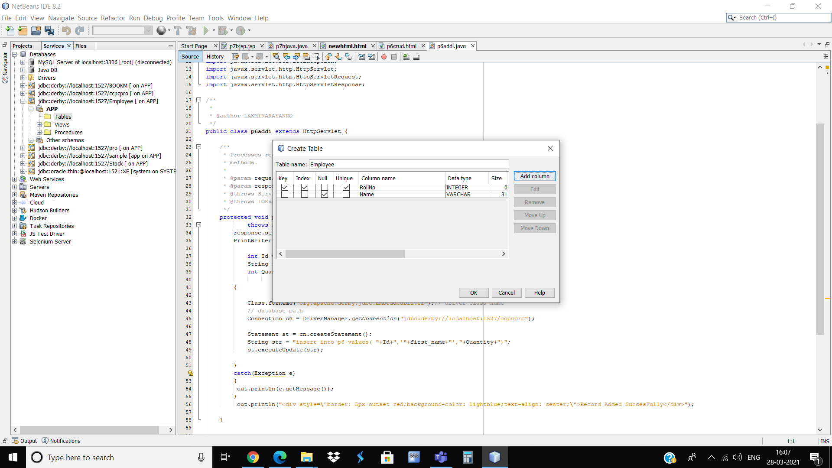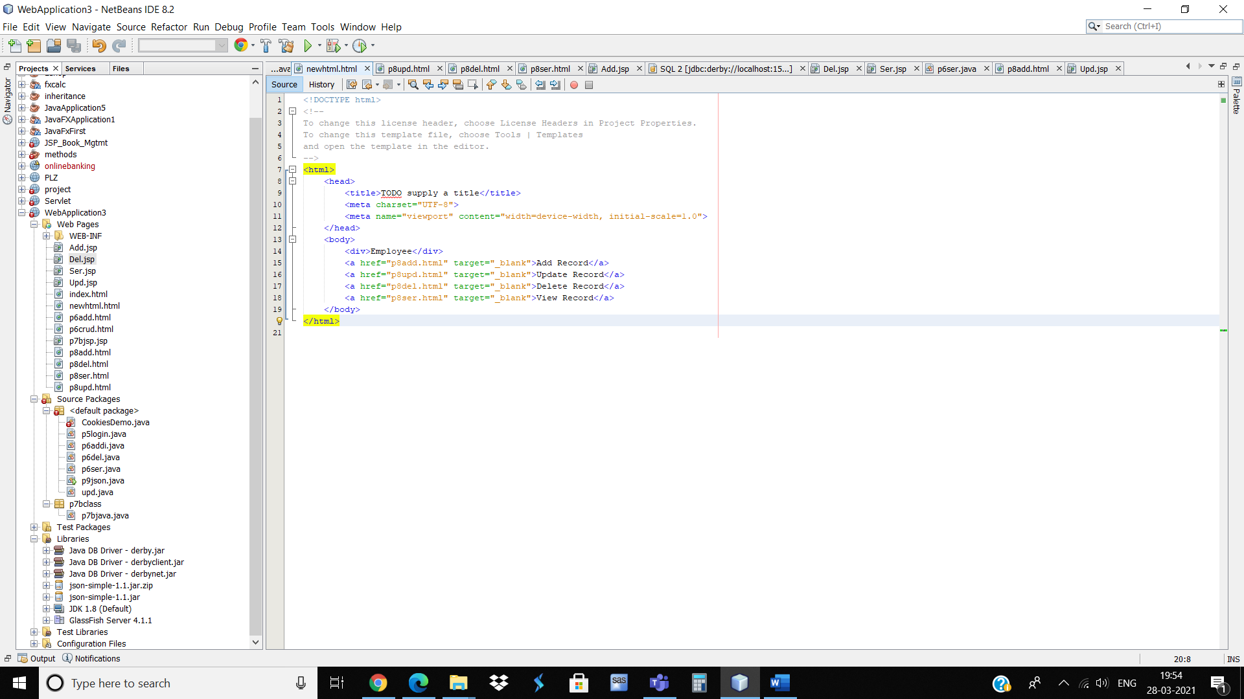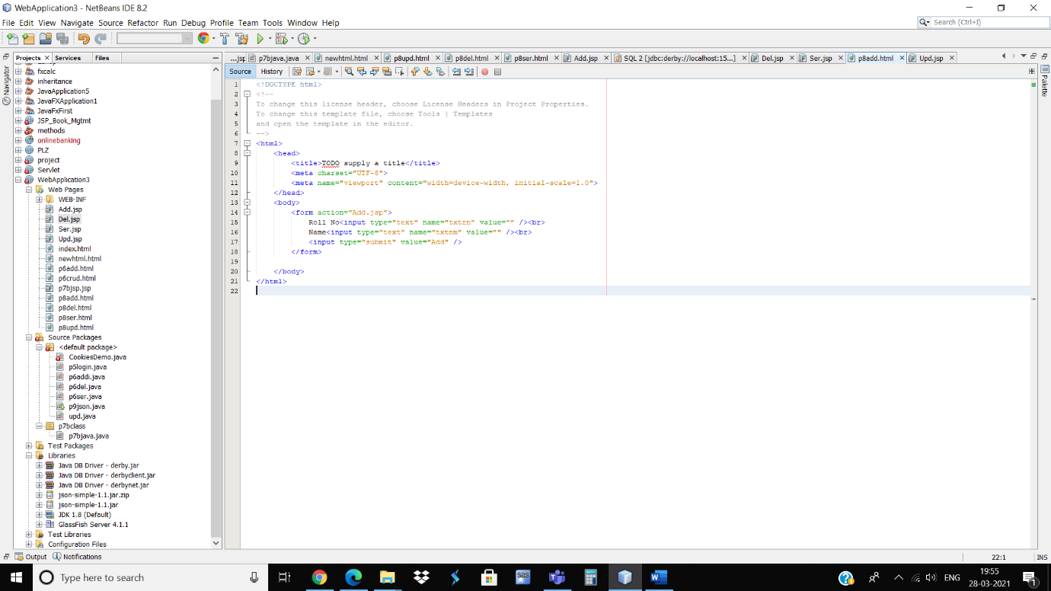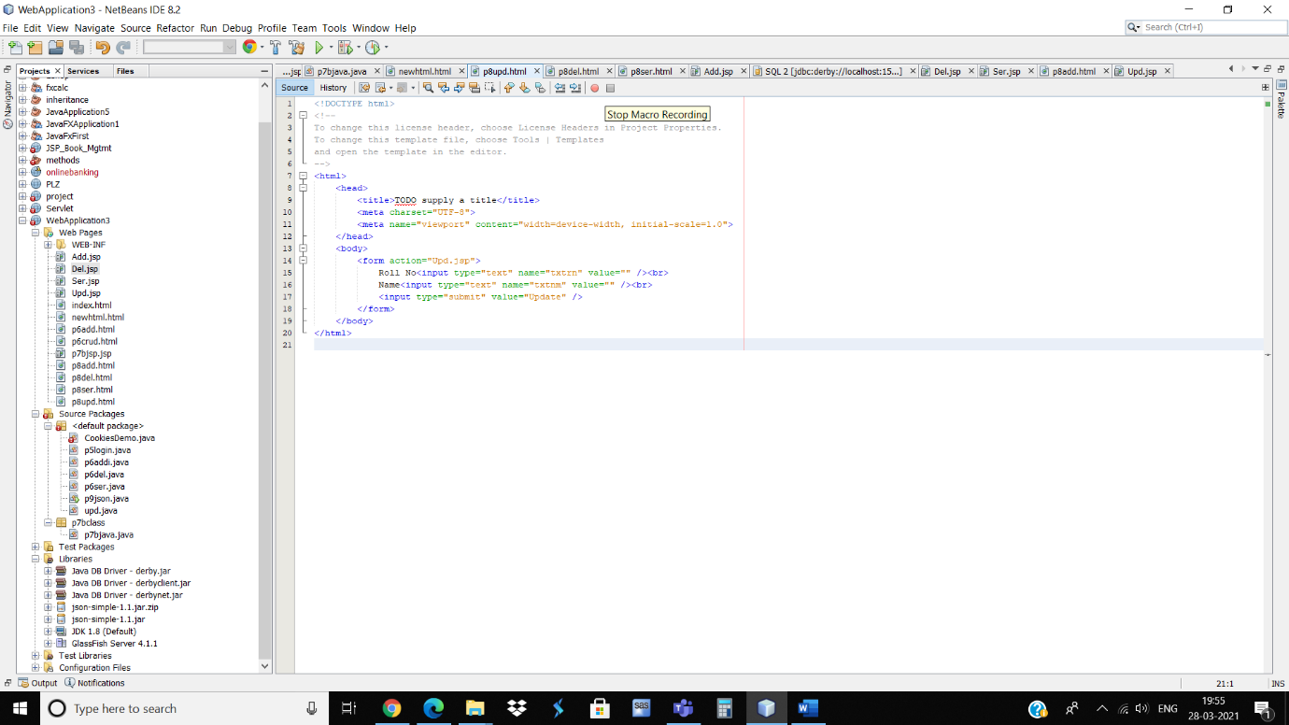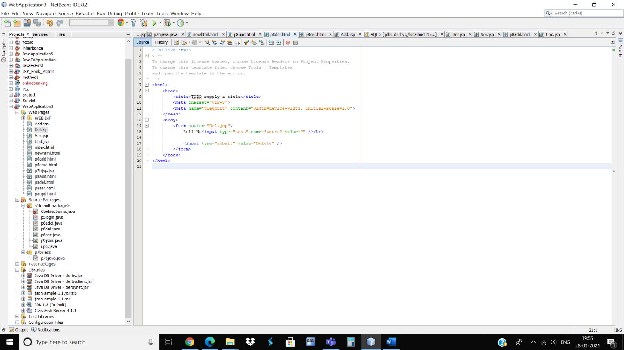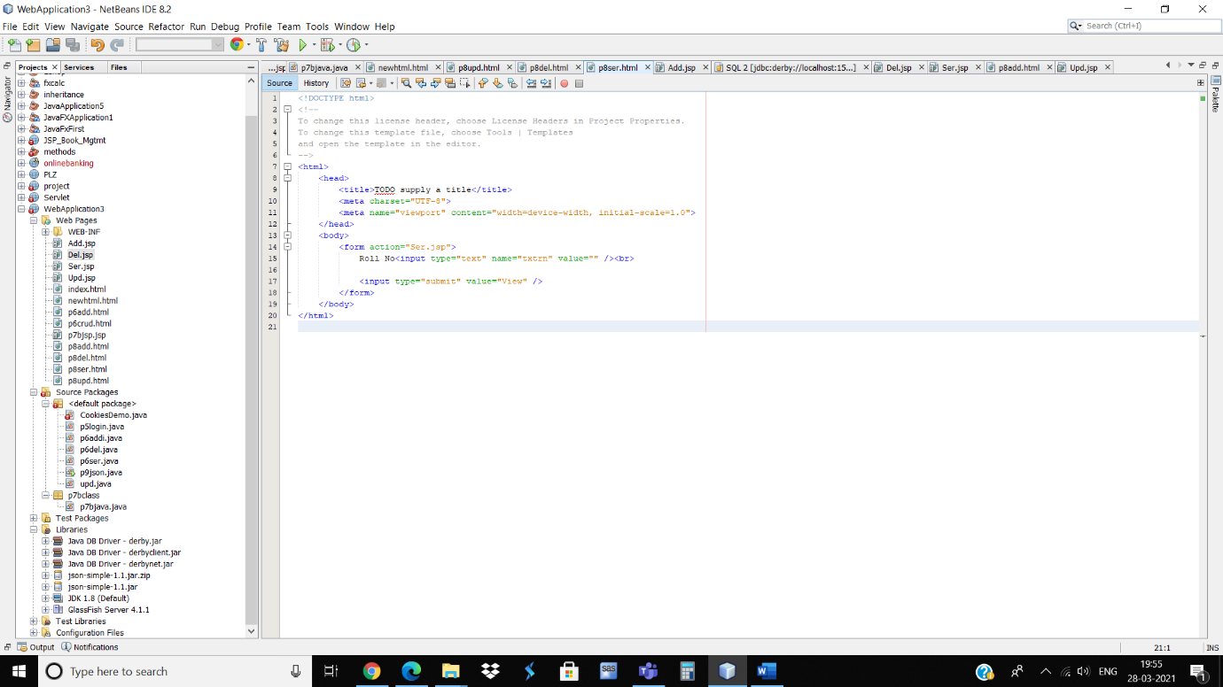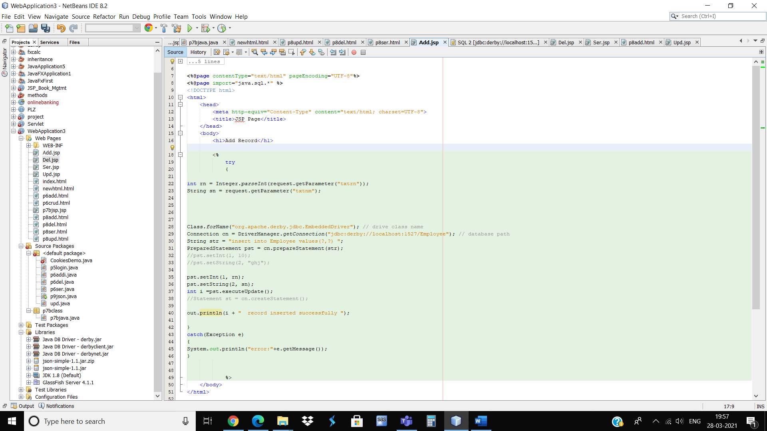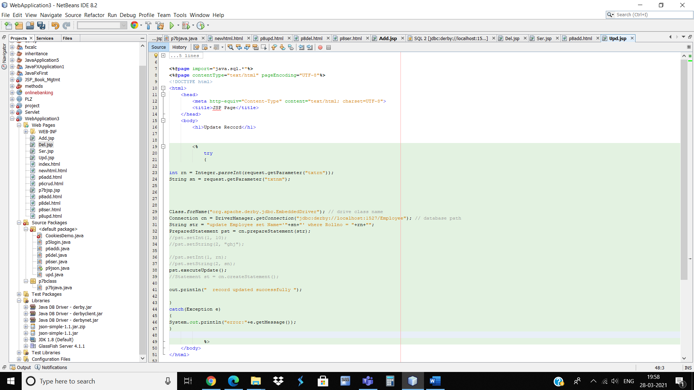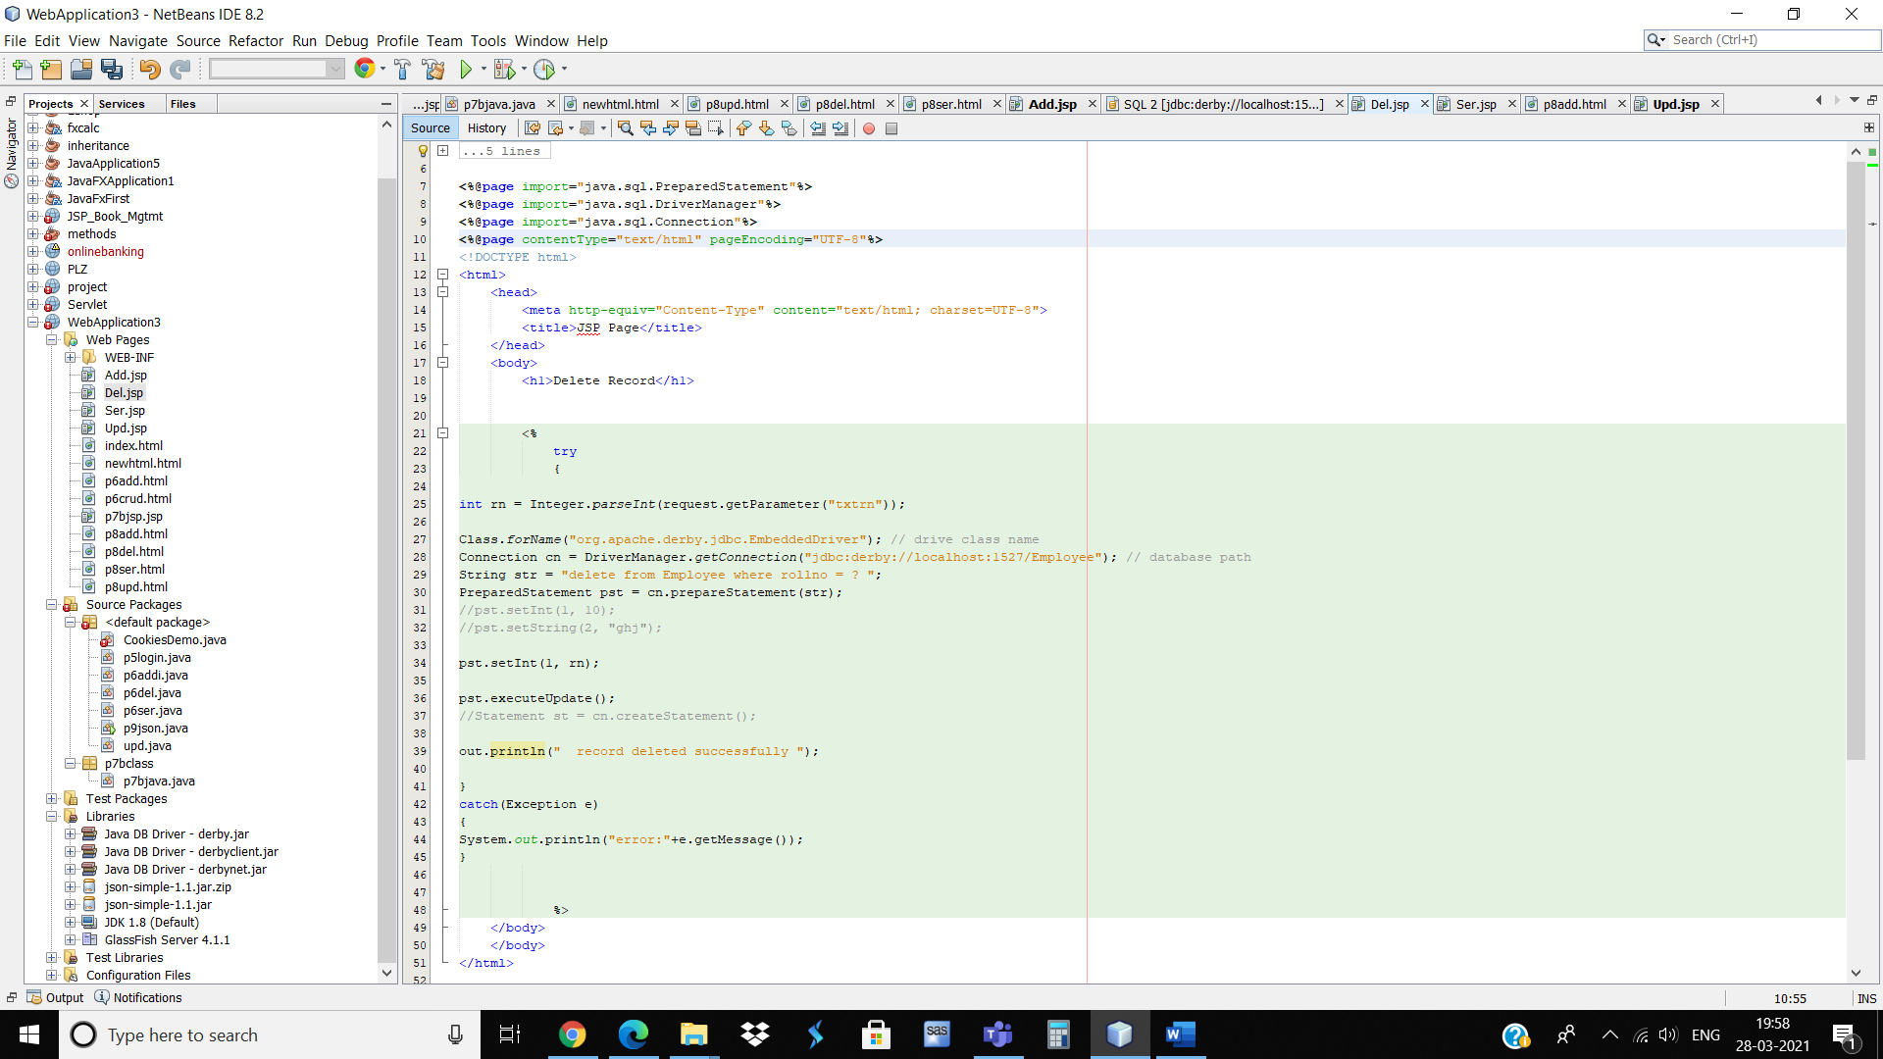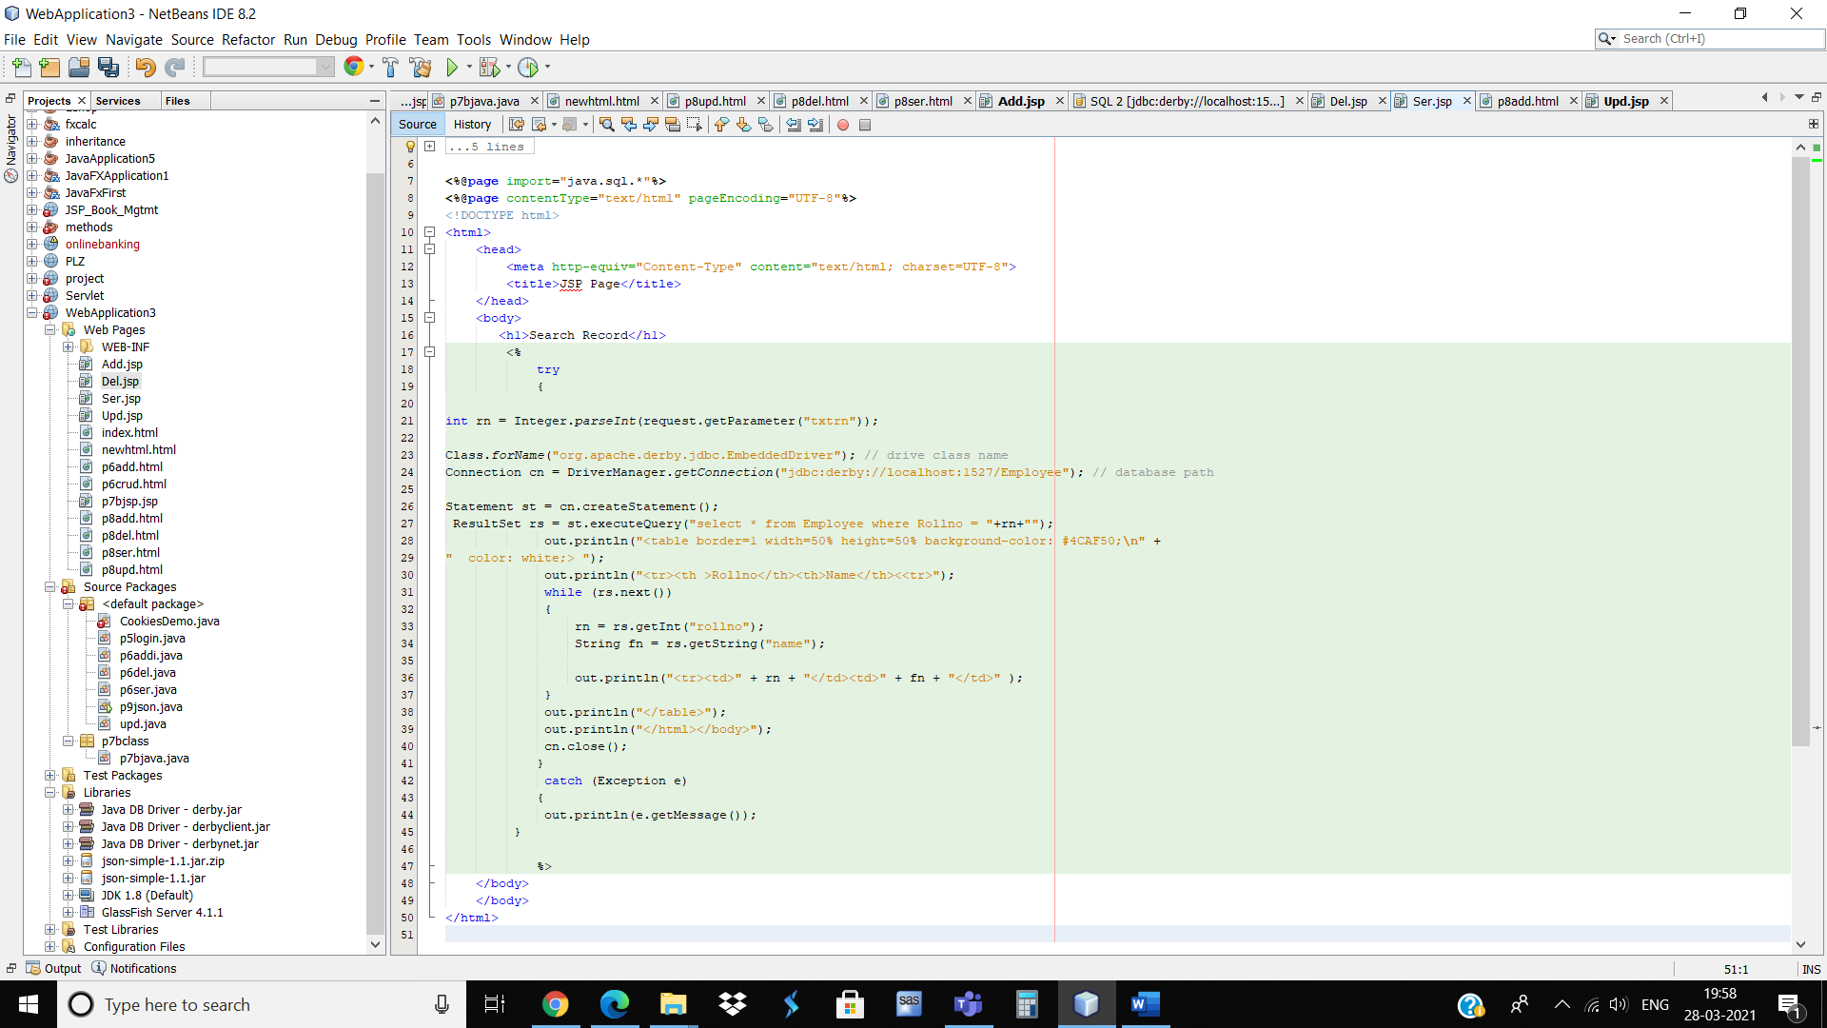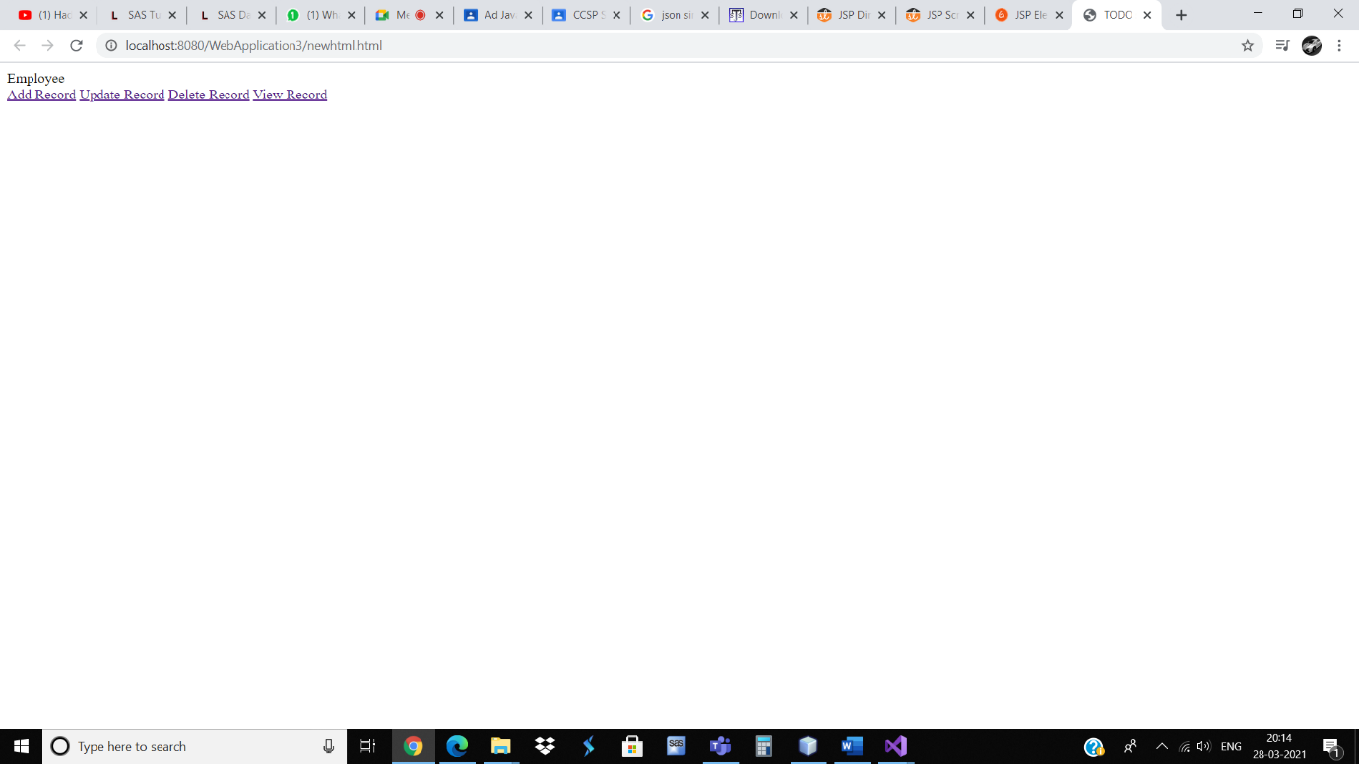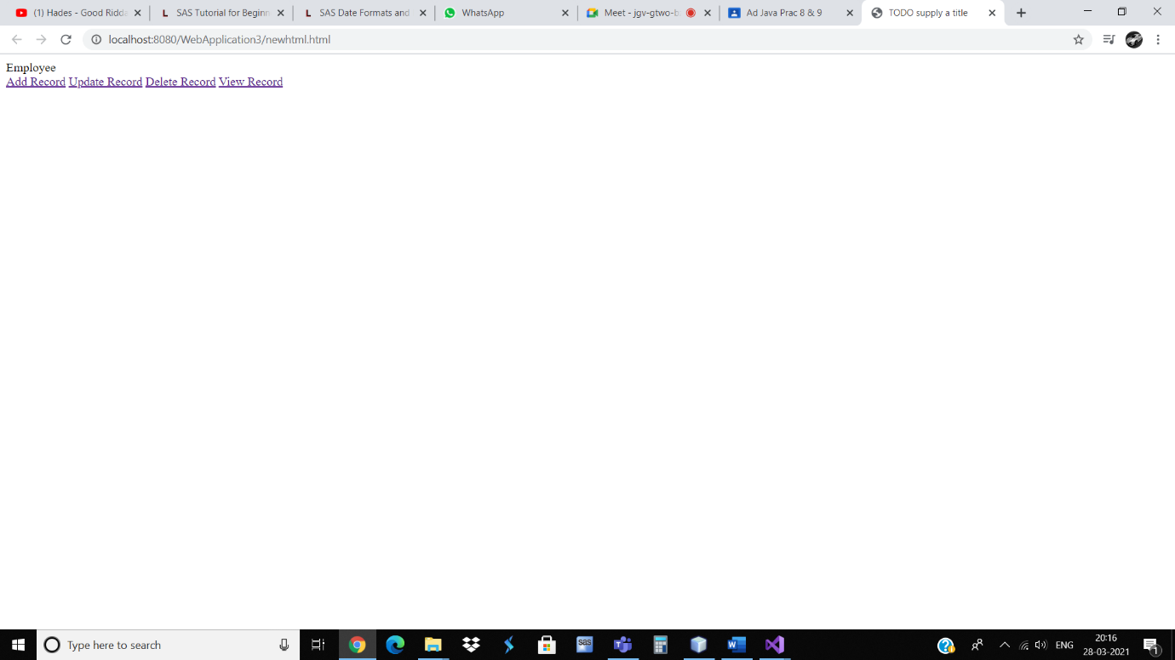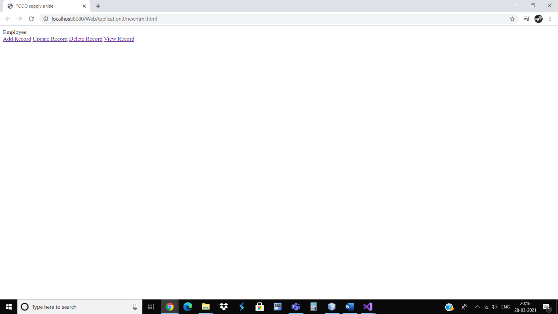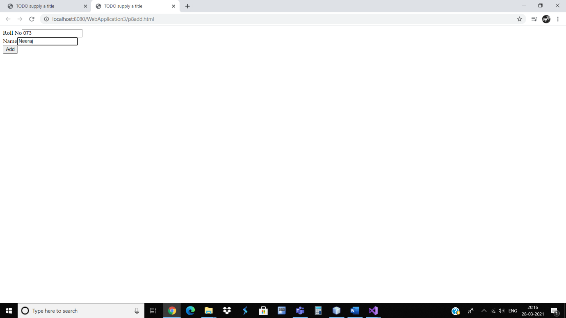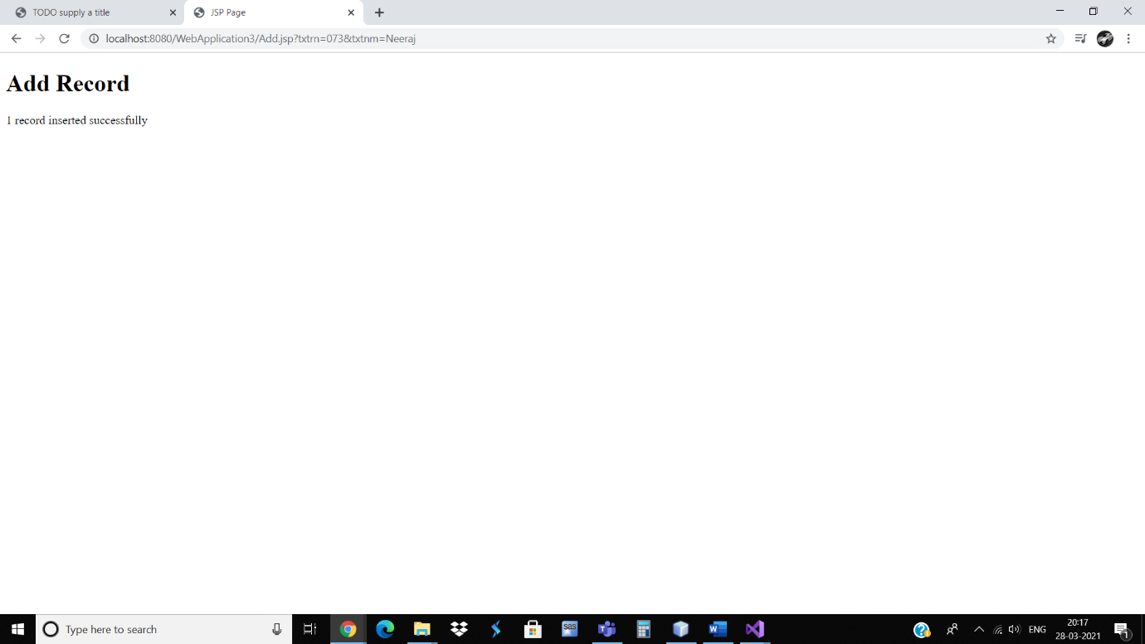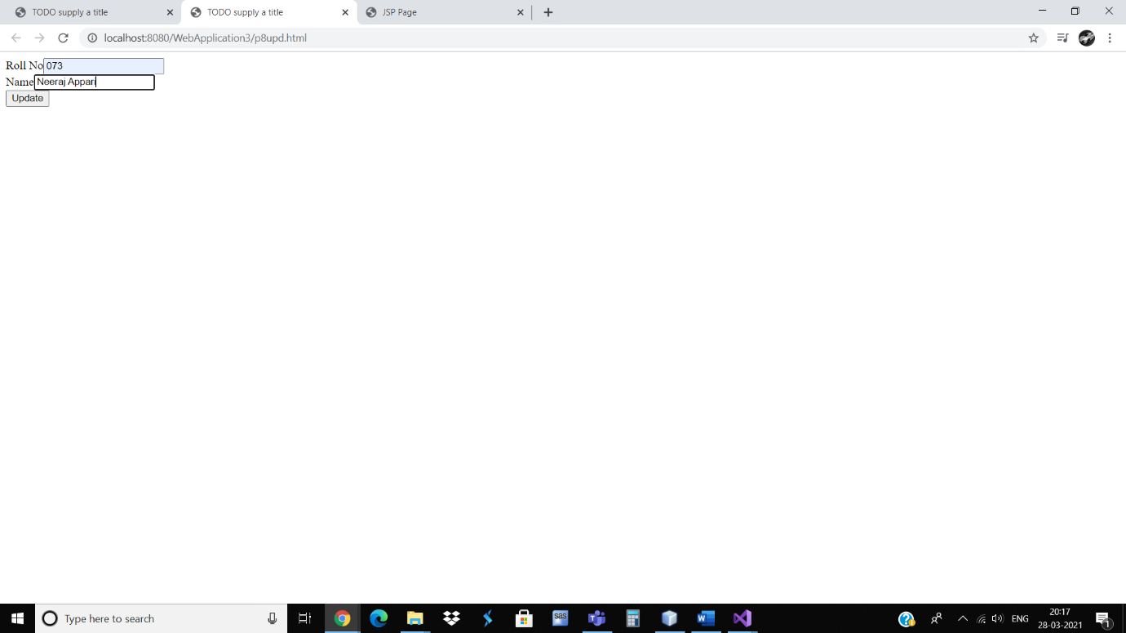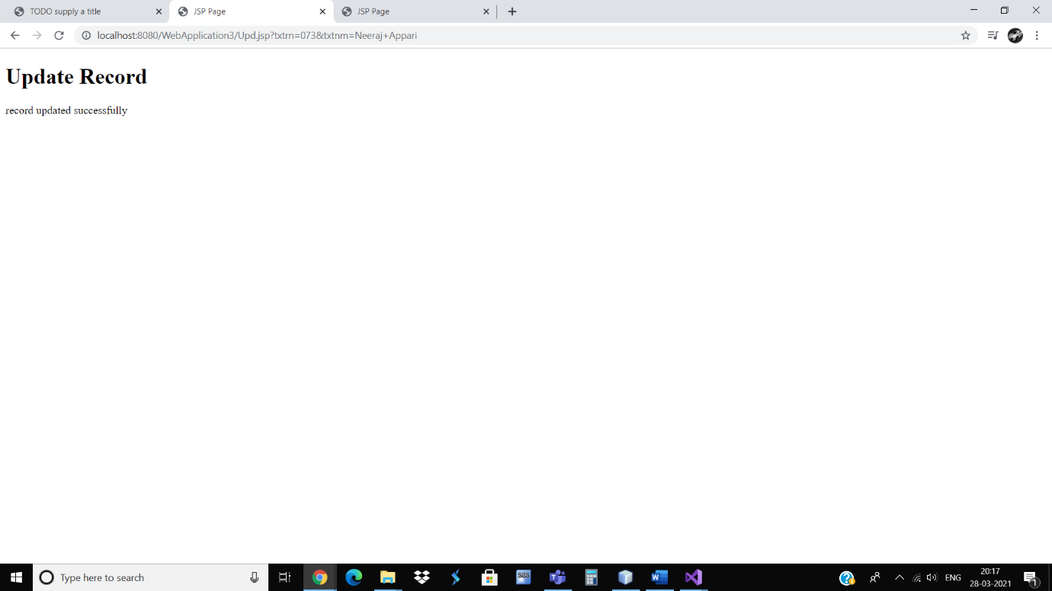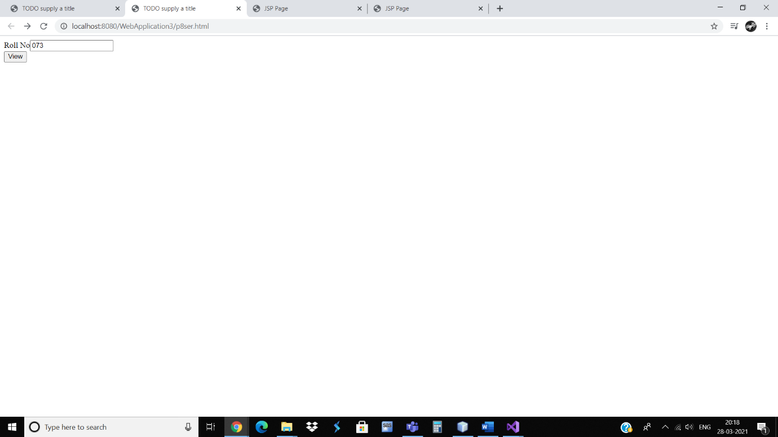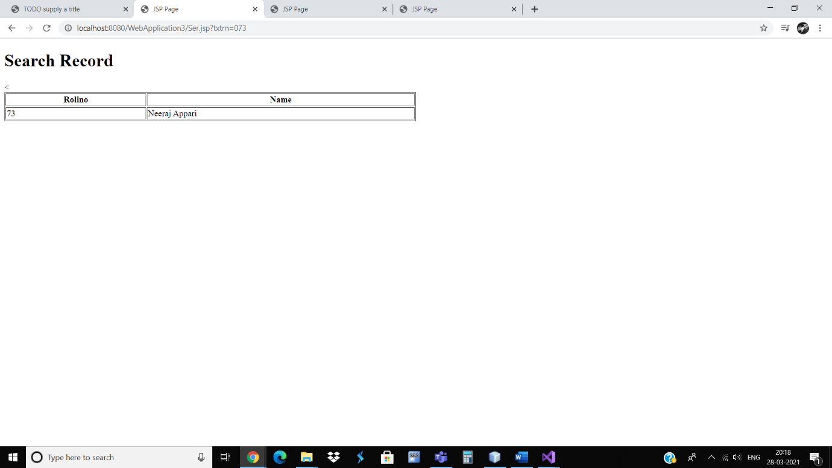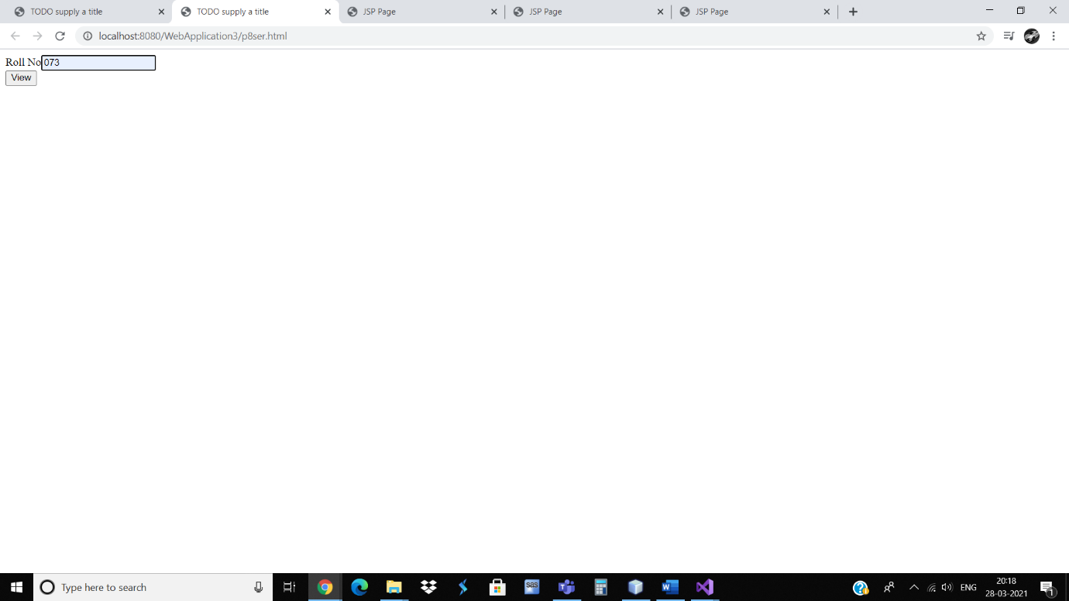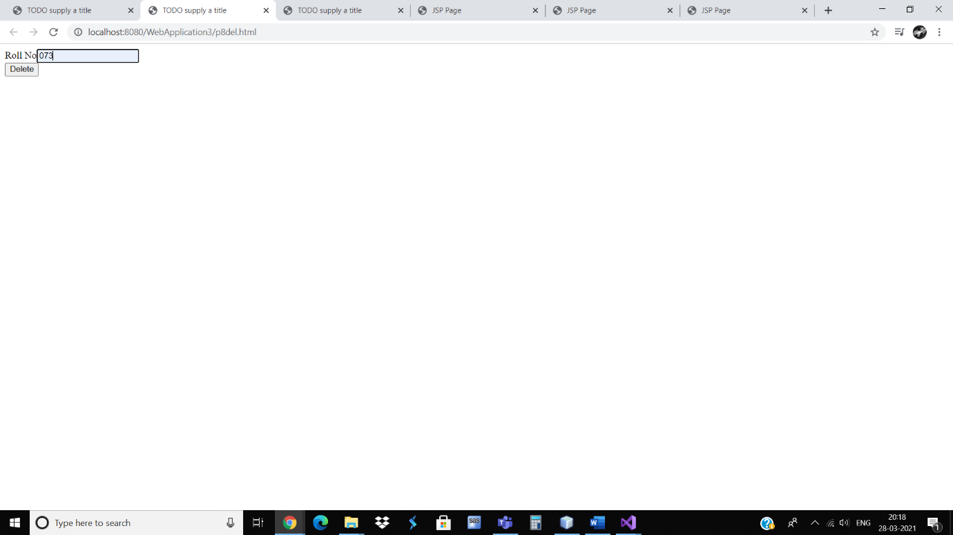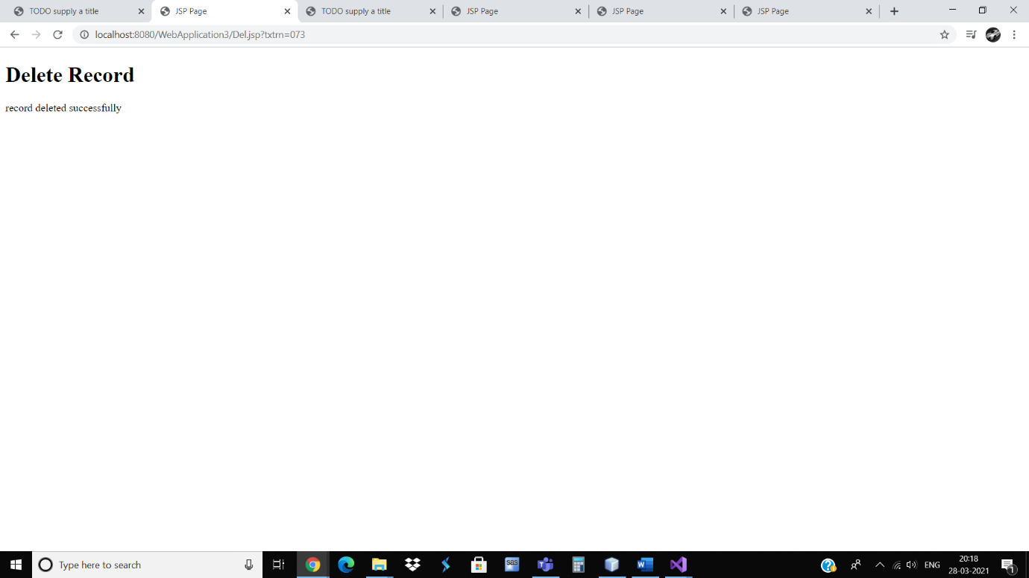

Advance Java Practical 9

Aim: Write Java application to encoding and decoding JSON in Java.

JSON

[

{

"plant":

{

"fruit":"mango",

"color":"yellow"

}

},

{

"plant":

{

"fruit":"apple",

"color":"red"

}

}

]

Java

import java.io.*;

import org.json.simple.*;

import org.json.simple.parser.*;

public class p9json {

@SuppressWarnings("unchecked")

public static void main(String[] args) {

JSONParser jsonParser = new JSONParser();

try { FileReader reader = (new FileReader("E:\\oracle\\netbeans\\WebApplication3\\newjson.json"));

{

Object obj = jsonParser.parse(reader);

JSONArray fruitlist = (JSONArray) obj;

System.out.println(fruitlist);

fruitlist.forEach(emp -> parseEmployeeObject((JSONObject) emp));

}

} catch (Exception e) {

System.out.println(e.getMessage());

}

}

public static void parseEmployeeObject(JSONObject fruit)

{

System.out.println("SAEEL .P. SAWANT S102");

JSONObject employeeObject = (JSONObject) fruit.get("fruit");

String name = (String) employeeObject.get("name");

System.out.println(name);

String color = (String) employeeObject.get("color");

System.out.println(color);

}

}

